FADE Program Phase 1:

CAD Project Guide

By: Sean Oh

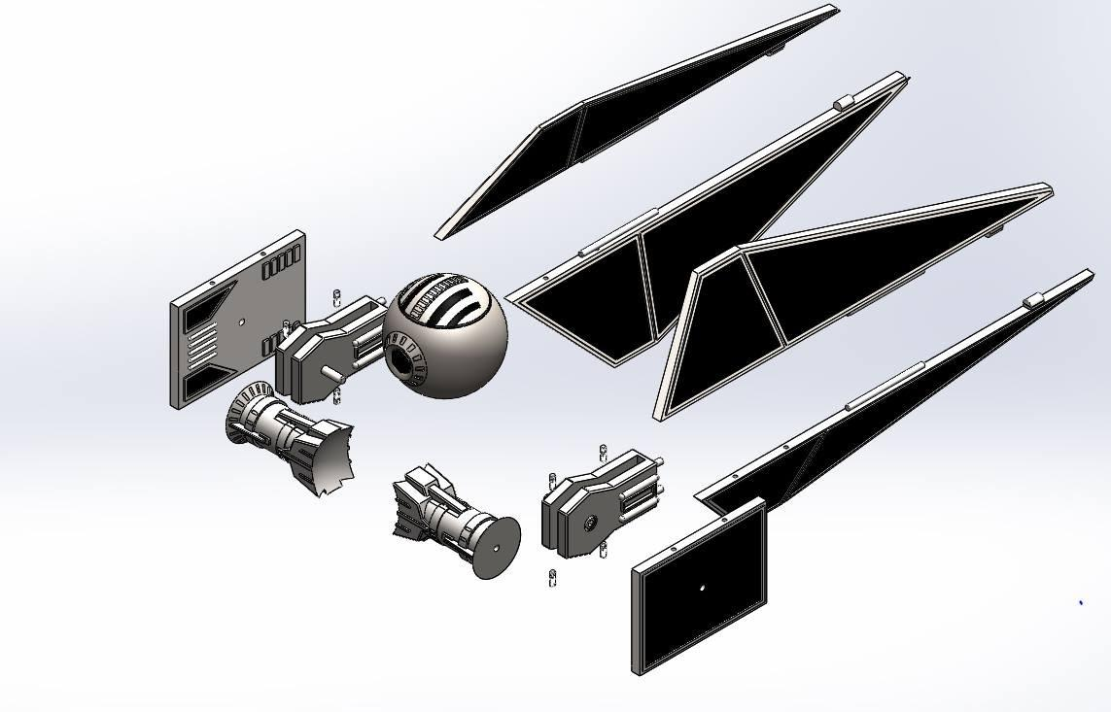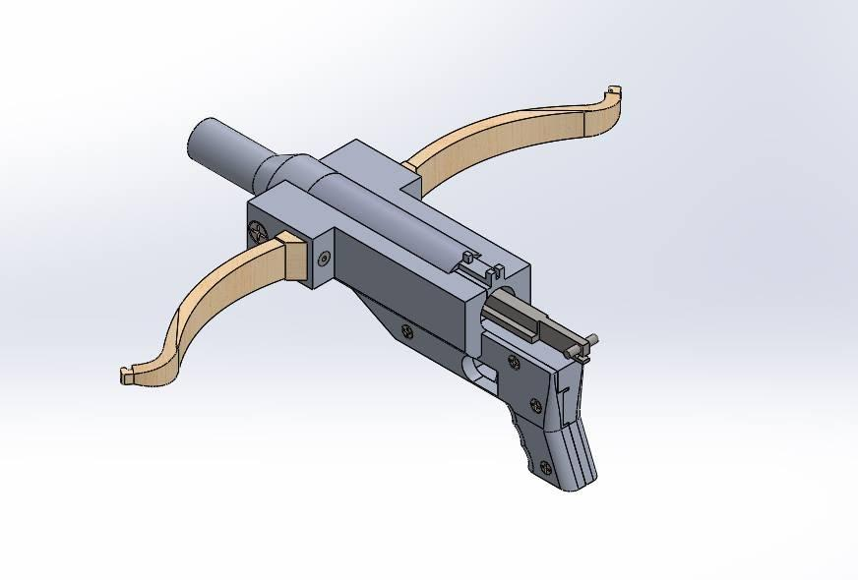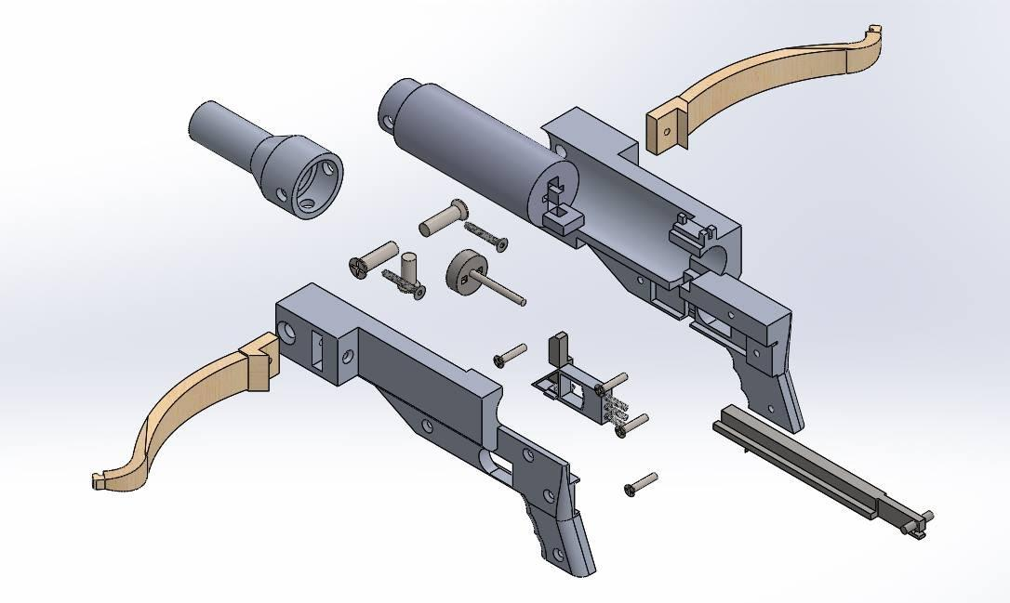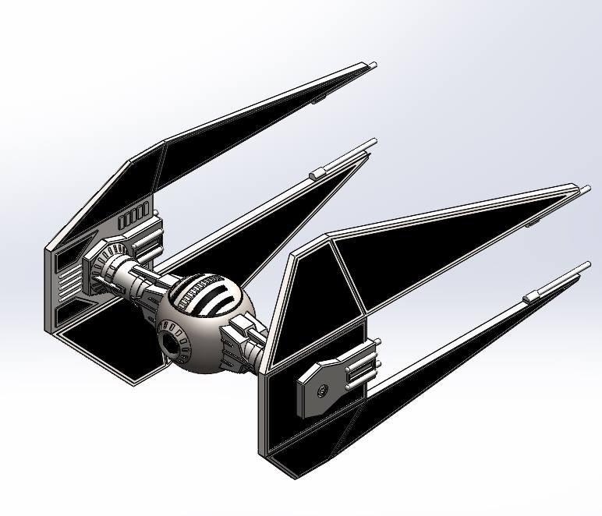

**Project Due Date**:

November 24th (Saturday), 2018, 11:59PM

**How To Submit:**

Email your zipped file (see #9) to [**asme.bruins@gmail.com**](mailto:asme.bruins@gmail.com), with email subject titled as:   
“FirstName_LastName_FADECADProject”

NOTE: If you are not familiar on how to use Solidworks, go through the tutorials available in the software, search video tutorials online, or check out our workshop videos.

@ https://www.asmebruins.com/fade-2018-2019-phase-1

**Project Guideline:**

This project is designed to allow you to show off what you learned from our CAD classes. We want you to design and CAD something that interests you. This can be anything: a military M-1 Tank, a fighter jet, rocket chair, Iron Man suit, longboard, etc. THIS IS COMPLETELY UP TO YOU. Be creative, and impress us! ***CAD submission approval is subject to review by officers, so go above and beyond!***

1. You must make at least 6 different parts in SolidWorks
2. Your assembly must include fasteners from both the SolidWorks Toolbox and McMaster-Carr
3. The final assembly must be constrained together (all parts must be connected and fixed)
4. Your assembly must use one part from McMaster-Carr that is NOT a fastener.   
   Raw materials **DO NOT** count either.
5. Your assembly must use at least three detailed design features. The detailed design features are things such as fillets, offset entities, trims, spline extrusions, etc.
6. Holes for the fasteners must be made using the Hole Wizard
7. All parts must have materials defined, use at least 3 different materials.
8. Create an engineering drawing of your assembly with the following views
   1. Front
   2. Top
   3. Right
   4. Orthogonal Projection
9. “Pack and Go” your final assembly and drawing files to a zipped file. Name your file “FirstName_LastName. zip”

Please defer any questions to you FADE Project Leads as well as your mentors. Good Luck!